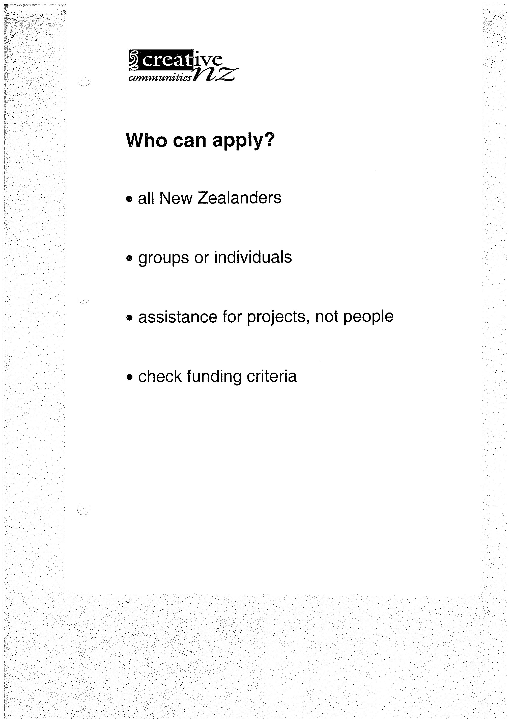
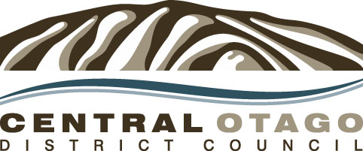
ARTS COUNCIL OF NEW ZEALAND TOI AOTEAROA

CREATIVE COMMUNITIES SCHEME
FUNDING LOCAL ARTS ACTIVITIES

APPLICATION FORM 2014-15

Applications close on Friday, 14 February 2014 at 4.00pm – (Note: late applications will not be considered).

If you require assistance please contact the Creative Communities Scheme Administrator at the Central Otago District Council office in Alexandra, phone (03) 440 0056.

For clarity please type or print in black ink. Applications are photocopied.

Send your application to: Central Otago District Council
1 Dunorling Street
PO Box 122
ALEXANDRA

Mark application for the attention of: Creative Communities Scheme Administrator

Local funding priorities for (2014)

Would you like to speak in support of your application at the assessment committee meeting?

Yes No

Check your Eligibility

Before you fill in this form, read the guide for applicants carefully to make sure you are eligible to apply, and find out about the types of projects that could and cannot be funded.

If you are not sure that you can apply, contact the scheme administrator.

Section 1 - Applicant’s details

Are you applying as an individual or as a group (select one) Individual Group

Full name of individual or group:

Address:

Post code: Telephone number(s):

Email:

What is the ethnic group that your or your group most identify with? (for example, New Zealand European, Maori or Samoan).

Section 2 - Description of your project

Briefly describe your project by answering the following:-

The idea/kaupapa – What is it you want to do?

The benefits – How will your project benefit your community?

The process How will you carry out you project, and where and when?

The people – Who is involved? (Include brief information about key individuals or organisations)

Section 3 - How much money are you requesting from the Creative Communities Scheme for this project?

$

(Please provide a detailed budget in section 8 of this application form)

What specifically are you applying for:

Section 4 - Which of the scheme’s three funding criteria are you applying under?

(Please select one only)

Broad community involvement – Your project will create opportunities to engage with and participate in arts activities.

Diversity – Your project will support the diverse arts and cultural traditions of local communities, enriching and promoting their uniqueness and cultural diversity.

Young people – Your project will enable and encourage young people (under 18 years to engage with and actively participate in the arts.
Section 5 - Which of the following is your project’s main artform?

(For an explanation of these terms, see the Glossary in the Guide for Applicants)

AF Arts Festival (multi-artform) CR Craft/Object art

DA Dance LT Literature

MU Music NM New media e.g. film making/digital arts

TH Theatre VA Visual Arts

Section 6 – Which of the following activities best describes your project?

COAW Creation of artwork CRPN Creation and presentation of artwork

EXBN Exhibition / presentation PERF Performance

WORK Workshop

Section 7 – What is the cultural tradition of your project?

M Maori

PI Pacific Island (if possible specify, eg Samoan, Cook Island Maori, Niuean, Fijian)

E European / North American (if possible specify, eg Celtic, Dutch, Hungarian, American)

A Asian (if possible specify, eg Southeast Asian, Chinese, Korean, Indian)

MELAA Middle Eastern, Latin American, African (if possible specify)

MC Multi-cultural

O Other (if possible please specify)

Section 8 - The budget

Are you registered for GST? Yes No

Please Note:
- Applicants that are not GST – registered need to provide budget figures that include GST
- Applicants who are GST – registered need to provide budget figures that exclude GST.

Successful applications who are GST-registered must submit a separate GST invoice. Contact your local scheme administrator for more information.

Include copies of written quotes.

Project Costs e.g. materials, venue hire, promotion, equipment hire, personnel costs

Item Amount

$

$

$

$

A. Total cost $

Project Income e.g., ticket sales, sale of artwork, etc
Amount

$

$

$

$

Other sources of income e.g., other grants, donations, discounts on services, own contribution, existing funds, expected fundraising.
Amount

$

$

$

$

A. Total funds available $

Please work out below the amount of funding requested.
The total cost of the project (A) minus total funds available for the project (B) will usually equal the amount requested from the Creative communities Scheme.

A. Total cost of project $

B. Less total funds available $

C. Difference $

D. Amount requested $

Section 9 - Financial Background

Tell us about any other funding you have applied for or received for this project.

Date Applied | Source of funding | Type of funding  (e.g. a loan/grant and what it will be used for) | Amount requested | Is funding confirmed? If yes state how much.  If you are still waiting for response, when will you know the result?

Tell us about any other grants you have previously received through the Creative Communities Scheme.

Date | Project title | Have you completed a project completion report for this project?  Yes/No | Amount of funding received

If you are a registered group or organisation (such as a charitable trust or incorporated society), provide a copy of your latest set of audited accounts.

Please provide bank account details (or deposit slip) for the payment of your grant.

Section 10 - Declaration

I/We declare that the information supplied here is correct.

If the application is successful, I/we agree to:

- Complete the project within a year of the funding being approved

- Complete and return a project report form (which will be sent with the grant) within two months after the project is completed

- Participate in any funding audit of my organisation or project conducted by the local Council if required

- Inform the scheme administrator of any public event or presentation that is funded by the scheme

- Acknowledge the assistance of the scheme verbally at event openings, presentations, performances and such like

- Use the CCS logo in publicity for the project and follow the guidelines for use of the logo. (Logo and guidelines can be downloaded from: www.creativenz.govt.nz/resources)

I understand that the Central Otago District Council is bound by the Local Government Official Information and Meetings Act 1987. I also consent to it recording the personal contact details provided in this application, retaining and using these details, and disclosing them to Creative New Zealand for the purpose of evaluating the Creative Communities Scheme. I understand that my name and brief details about the project may be released to the media or appear in publicity material. I undertake that I have obtained the consent of all people involved to provide these details. We understand that I have the right to have access to this information. This consent is given in accordance with the Privacy Act 1993.

Name:

Signature:

Signature of parent or guardian if applicant is under 16 years of age:

Position in organisation:
(If applicable)

Date:

Section 9 - Final Checklist

Have you done all of the following?
(Tick as appropriate)

completed all sections?

checked that the budget balances?

provided full financial details?

provided contact details?

signed the declaration?

Guide for Applicants

The Creative communities’ scheme is a partnership between Creative New Zealand (the national arts development agency) and local Councils in New Zealand. Each Council takes responsibility for delivering the scheme in is area.

Local decision – making is the key to the scheme: applications are considered by assessment committees with knowledge and experience of the arts in their area.

Purpose of the scheme

The Creative Communities’ scheme supports and encourages local communities to create and present diverse opportunities for access and participating in arts activities within their specific geographical area, as well as for defined communities of interest.

Under the scheme “the arts” is defined as “all forms of creative and interpretative expression”.

Who can apply?

- An application can be made from an individual or from a group.

- Individual applicants must be New Zealand citizens or permanent residents.

- If you have previously received funding under the Creative Communities Scheme, either as an individual or as a member of a group, you must have completed a project report for the earlier project before any further applications from you will be considered.

Can I get funding for my project?

The project must –

- have an arts or creative cultural focus

- meet one or more of the three funding criteria (see below)

- be completed within 12 months after funding is approved

- benefit local communities

- take place within the city or district where the application is made, or benefit local communities within that city or district

- not have started before funding is approved

- not have already been funded through Creative New Zealand’s contestable funding programme for the same purpose

- not have already been funded through creative New Zealand’s multi-year funding programme

Funding criteria

Your project must meet one or more of the following funding criteria –

- Broad community involvement – the project will create opportunities for local communities to engage with and participate in arts activities

- Diversity – the project will support the diverse arts and cultural traditions of local communities, enriching and promoting their uniqueness and cultural diversity

- Young people – the project will enable and encourage young people (under 18 years) to actively participate in the arts

Types of projects or activities that could be funded include –

- Exhibitions, productions, concerts, festivals, workshops and presentations that offer opportunities for community involvement in the arts

- Activities that support the traditions and arts of ethnic communities

- Youth arts events

- Artist – led projects involving local communities

- Materials for arts activities or programmes

- Personnel costs for one-off, short-term projects

- Promotion and publicity of arts activities to communities

Types of projects or activities that cannot be funded include –

- Activities that are not art focused

- Activities that are the direct responsibility of schools or other education institutions

- Ongoing administration costs not related to a specific project

- Projects that are the core business of an organisation or service provider

- Retrospective project costs (for projects already started or completed)

- Catering costs of an event

- Fundraising activities

- Developing facilities, such as gallery and theatre lights, stage curtains or building restoration

- Buying capital items or equipment, such as cameras, computers, instruments, costumes or uniforms

- Applications cannot be accepted for further funding on the same or similar project that you have received funding for previously e.g. an annual exhibition, a festival that has been funded before

