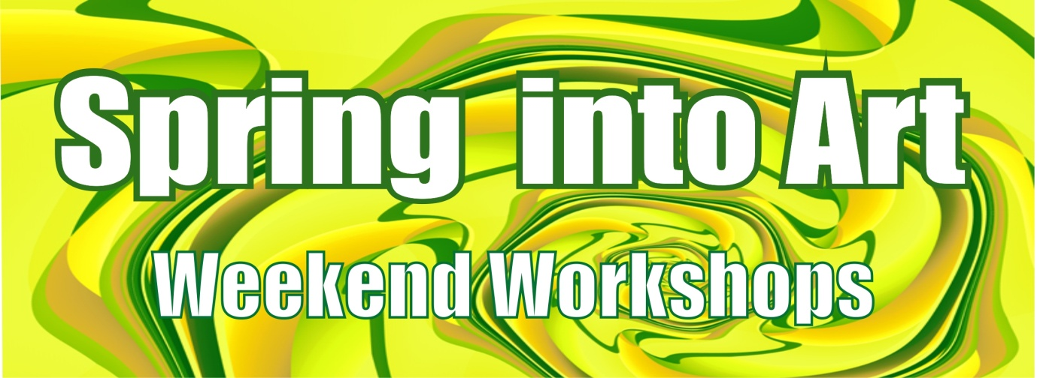
TEVIOT ARTS SPRING INTO ART REGISTRATION FORM

Teviot Arts Inc is offering a weekend of art workshops in September, featuring an exciting line-up of local and visiting tutors. This is a wonderful opportunity for you to try something new, meet interesting people and get creative.
WHEN: September 20th (full day) & Sunday 21st (half day)
COST: All workshops cost just $30 per person. Book now - limited spaces!
MORE INFO: Phone 03 4466 582 or Email: oldmooner@gmail.com

Name: __________________________________________________________________________
Address: _________________________________________________________________________
_________________________________________________________________________________
Phone: ____________________________________ Cell: __________________________________
Email: _____________________________________
Payment made by: Cheque or Bank Payment (please circle) Payment amount: _______________
Preferred workshop: ___________________________________________________
Second choice :________________________________________________________

Registration and payment must be made before the 12th of September.
Please make cheques and online payments to Teviot Arts Inc.
Account number: 0916 0121048 00 Please make sure you reference payment: Your Name
Mail registration forms and cheques to: Vauna Turner, Dalmuir Rd, RD2 Ettrick.
Applicants will be advised of confirmed registration ASAP and a receipt will be posted.

